AGV HMI Application

Project Description:
For the final project for CEE-445, we will be designing an Android app to control and view feedback from our Automated Guided Vehicle (AGV) Capstone project. At the heart of the AGV is a Raspberry Pi 4 that is responsible for managing feedback from a LIDAR sensor and dictating motion instructions to an onboard Arduino to drive the AGV. Since we have no way to interact with the device beyond accessing the Pi with an SSH connection, we would like to kill two birds with one stone and design an Android app to connect to the Pi via Bluetooth and provide an HMI for the AGV, while using it as the final project for CEE-445. The Pi will take in feedback from the LIDAR and motor control board, and provide it to the app. The user of the app can then use this feedback to dictate control of the AGV. The instructions will be sent back to the Pi from the app via Bluetooth and can be used to control the AGV.

Project Sketch/Diagram

Example:

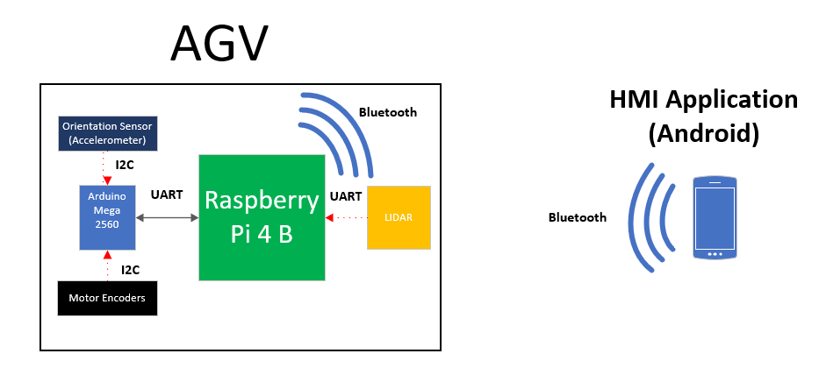

Bill of Materials:
All materials are provided from Capstone Project:
Phone: Android (student-provided)
Board: Raspberry Pi 4 B
Sensors: LIDAR and Arduino Mega 2560 (feedback)

